**GEOG 288CJ Homework-01**

Ian Baxter

**1) Review the definition of adiabatic lapse rate and static stability. A good reference is Wallace and Hobbs Atmospheric Science: an introductory survey**

Adiabatic lapse rate: The rate of change for the temperature of a parcel of air that is being raised or lowered in the atmosphere without losing or gaining heat.

Static stability: Refers to the restoring force of the atmosphere, in which vertical mixing is inhibited by greater stability. Static stability is commonly computed as change in potential temperature over change in height.

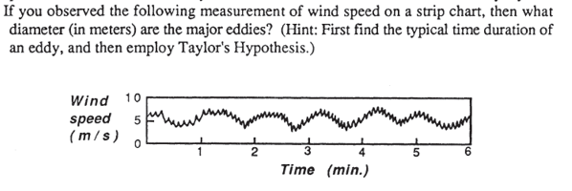**2)**

The diameter of the major eddies (lambda) based on Taylor's hypothesis are...

P = lambda / M

lambda = P * M

lambda = 60 s * 5 m/s = 300 m

**3) Would there be a boundary layer on a planet that had an atmosphere. but that did not experience a diurnal variation of net radiation at the ground?**

Yes, there would be a boundary layer on a planet that has an atmosphere. There will be a boundary layer as long as there is an atmosphere because there will still be a distribution of momentum and heat fluxes associated with the surface. As long as there is heat coming off of the surface or winds passing over the surface (and being affected by friction), there will be a boundary layer. Even at night on Earth there exists a boundary layer.

**4) There are four radiosonde profiles in Gaucho Space named A, B, C and D. In each file, columns have time (s), Pressure level (hPa), Air Temperature (C), Relative Humidity (%), Wind Speed (knots), Wind Direction (degrees), Altitude (m) and Geopotential Height (m)**

**4a) For each sounding, compute the water vapor mixing ratio, potential temperature and virtual potential temperature. Use surface pressure the value at t=0**

See html (I couldn’t output into a pdf from jupyter)

**4b) For each sounding, make vertical profile plots of mixing ratio, temperature, virtual potential temperature and wind speeds. Limit the plots to elevations 0-3000 m so that variations can be better seen.**

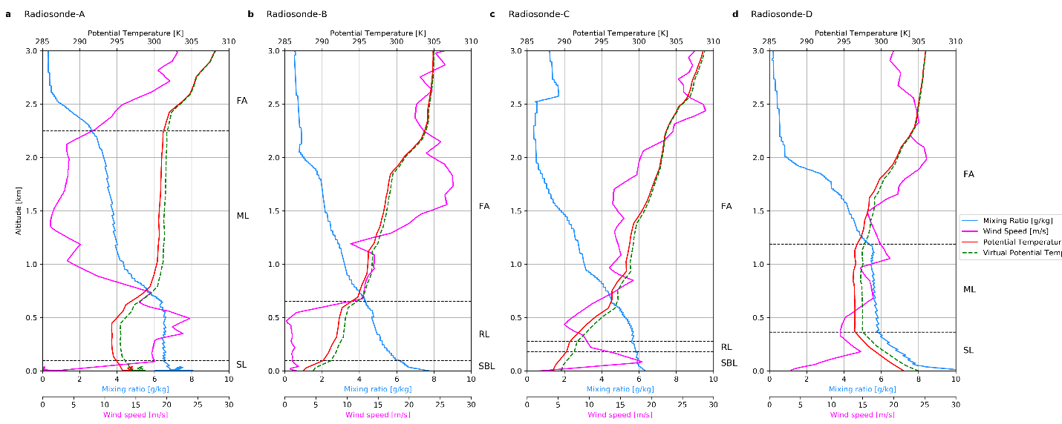

**4c) Discuss each profile and identify (if possible) surface layer (SL), mixed layer (ML), stable boundary layer (SBL) and free atmosphere (FA)**

Radionsonde-A has a very well mixed layer, where potential temperature and virtual potential temperature barely changes vertically for 1.5 km.

Radiosonde-B has a very stable atmospheric structure.

Radiosonde-C

Radiosonde-D is very unstable near the surface, to the point of being super adiabatic, beneath a well-mixed layer. The rapid decrease in potential temperature with height, is indicative of this instability and suggests that this may be an afternoon profile. It may be that solar radiation over the duration of the day and warms the surface, the near surface air becomes more buoyant and creates turbulence.

**4d) Estimate the top of the BL in each sounding**

Radiosonde-A: ~2.5 km

Radiosonde-B: ~ 625 m (if counting residual layer), 100 m (if not counting residual layer)

Radiosonde-C: 180-280 m

Radiosonde-D:

**4e) Associate each sounding with early morning, noon, afternoon, late afternoon and night. Discuss and justify your answers.**

Radiosonde-A: Afternoon

Radiosonde-B: Early Morning

Radiosonde-C: Noon

Radiosonde-D: Late Afternoon